1. Design NFA using simulator to accept the input string “bbc” ,”c”,and ”bcaaa”.

INPUT:

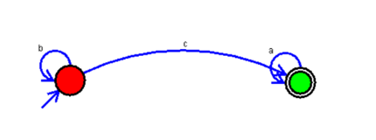

OUTPUT:

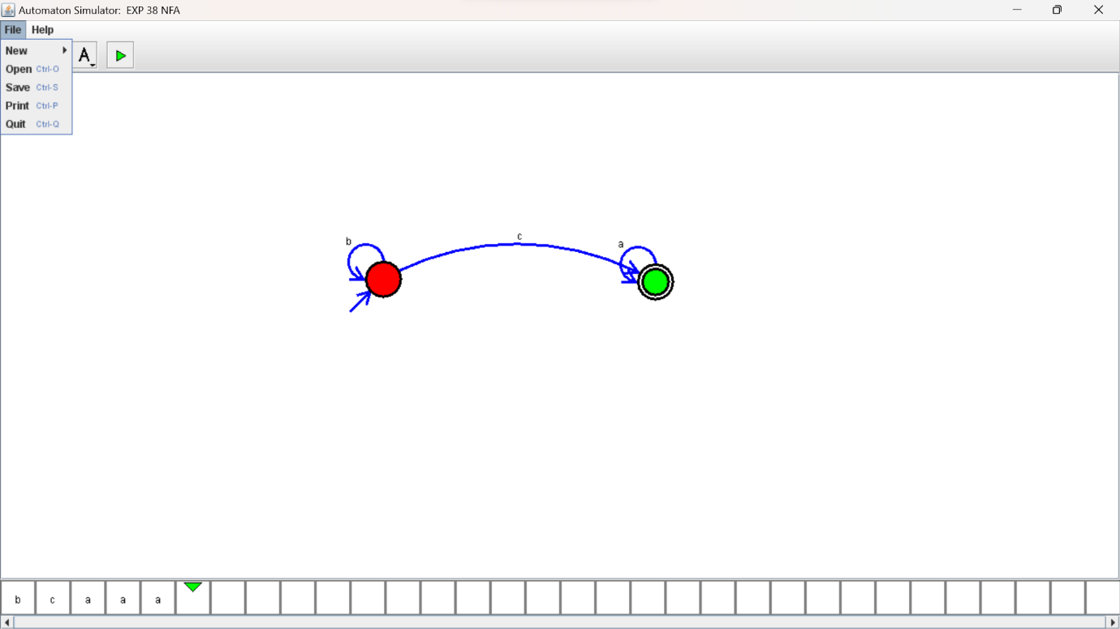

RESULTS:

NFA using simulator to accept the input string “bbc” ,”c”,and ”bcaaa”.